YETI HOLDINGS, INC.
Strategic Consulting Report

Written by: Malakhi Gregory, William Wallace, and Sejal Wellington
March 19, 2026

March 31, 2026

Dr. Whitehouse
BUAD 441W
University of Lynchburg

Dear Dr. Whitehouse,

We are pleased to submit this Strategic Consulting Report on YETI Holdings, Inc. All of the feedback and guidance is much appreciated throughout the entire team, and we are confident that we checked all the boxes with our final submission.

The report includes a financial analysis, a macro-environmental analysis, a SWOT analysis, strategic and financial objectives, base case financial projections, and our recommendations for improving YETI's long-term performance. Each section was researched and supported by the exhibits found in the appendix found at the end of the paper.

We have worked to incorporate all of your comments and corrections into this revised version. Please do not hesitate to reach out if you have any further questions or concerns.

Respectfully submitted,

Malakhi Gregory, William Wallace, and Sejal Wellington

Executive Summary
This report provides a financial analysis, SWOT analysis, and macro-environmental analysis, as well as other critical information surrounding YETI Holdings, Inc. and its competitors. All of the information provided is supported further by the tables, graphs, and charts found at the end of the report. YETI’s potential for long-term growth, as well as possible challenges that have been and may be faced, are all addressed throughout this report.
The DuPont Analysis reveals possible concerns with margin pressure from increased costs, as well as a variety of other challenges. Still, YETI shows strength in financial stability, liquidity, leverage, and profitability. As identified in the SWOT analysis, YETI works to maintain strong premium brand loyalty, stay technologically up to date, and ensure leverage with changes taking place in the industry. There are also several areas for YETI to monitor going forward, which will be addressed in further detail throughout this report.
The PESTEL and Porter’s Five Forces analyses show that for YETI to remain competitive in this market, it will need to keep pace with technological advancements, political conditions, regulatory changes, and competitive pressures throughout the industry. Because of this, the report identifies the key success factors needed to thrive in this industry. Specific recommendations have also been made for YETI to implement in order to improve its chances of long-term success, along with a look at the financial consequences of making or failing to make those changes.

Key Success Factors (KSFs)
In order to succeed in this market, competitors must demonstrate the following capabilities:
- Strong premium brand equity: Brand recognition and customer loyalty are essential for commanding premium prices and defending market share against lower-cost competitors.
- Advanced direct-to-consumer (DTC) platform: A seamless digital and in-store experience is critical to capturing customer data, improving margins, and reducing dependence on third-party retailers.
- Customer data analytics: The ability to understand purchasing trends, preferences, and behaviors allows companies to refine product development and marketing strategies.
- Efficient global sourcing: Maintaining cost-effective and reliable supplier relationships across international markets is necessary to manage costs and ensure product availability.
- Product innovation capability: Continuous development of new and improved products keeps brands relevant and attractive to evolving customer needs.
- Marketing and lifestyle branding: Effective storytelling and lifestyle-centered advertising help brands build emotional connections with their target audience.
- Sustainable materials: Growing consumer and regulatory expectations around environmental responsibility require companies to incorporate eco-friendly materials and practices into their supply chains.
- Supply chain flexibility: The ability to adapt quickly to disruptions, tariff changes, or shifts in consumer demand is essential for maintaining stable operations and margins.

Table of Contents
Executive Summary……………………………………………………………………………….3
Financial Analysis………………………………………………………………………………...6
Vision, Mission, and Core Values………………………………………………………………...7
Macro-Environmental Analysis…………………………………………………………………...8
Base Case Financial Projections…………………………………………………………………13
SWOT Analysis………………………………………………………………………………….14
Recommendations………………………………………………………………………………..15
Consequences…………………………………………………………………………………….16
Works Cited……………………………………………………………………………………...17
Appendix…………………………………………………………………………………………18

Financial Analysis
Founded in 2006, YETI Holdings, Inc. is a premium outdoor products company specializing in coolers, drinkware, and outdoor lifestyle products. This financial analysis reviews YETI’s performance from 2018 through 2024 using key financial ratios, including a DuPont breakdown to better understand what drives the company’s returns.
YETI’s liquidity remained strong throughout the period, even with some fluctuations. As shown in Figure 1, the current ratio increased from 1.59 in 2018 to 2.12 in 2019, dropped to 1.66 in 2020, and then rose to 2.69 in 2021. It later declined to 1.76 in 2022 before stabilizing at 2.30 in 2023 and 2.18 in 2024. The quick ratio followed a similar pattern over the full period, confirming that YETI consistently maintained the ability to meet its short-term obligations.
YETI’s solvency improved significantly over time. As shown in Figure 2, the debt to assets ratio steadily declined from 94.37% in 2018 to 42.45% in 2024, showing a lower reliance on debt. The long-term debt to equity ratio also decreased significantly over the period. These trends show that YETI reduced financial risk and strengthened its capital structure.
Profitability showed some ups and downs but remained solid overall. As shown in Figure 3, net profit margin dropped from 7.42% in 2018 to 5.52% in 2019, then increased to 14.27% in 2020 and 15.07% in 2021. It declined again in 2022 before recovering to 10.24% in 2023 and 9.60% in 2024. Gross profit margin remained consistently strong across all years, reaching 58.11% in 2024, showing that YETI continues to generate solid earnings.
Efficiency ratios were more mixed. As shown in Figure 4, accounts receivable turnover generally improved over time, while inventory turnover declined in later years before slightly recovering in 2024. Long-term asset turnover also decreased after peaking in 2021, showing reduced efficiency in using assets to generate revenue.
The DuPont analysis helps explain YETI’s returns. As shown in Figure 5, ROA increased from 11.23% in 2018 to 21.14% in 2020, then declined and recovered to 13.66% in 2024. ROE was extremely high in 2018 at 199.38% due to high leverage, but as leverage decreased to 1.74 by 2024, ROE stabilized at 23.74%. This shows that YETI’s returns are now more sustainable and less dependent on debt.
Overall, YETI shows improving financial stability. Liquidity remained strong, leverage decreased, and profitability stayed positive despite some fluctuations. YETI’s main strengths include strong profitability, improved capital structure, and stable liquidity. Weaknesses include fluctuating margins and lower inventory efficiency in some years. At the end of the day, YETI appears financially stable and positioned for continued growth.

Vision, Mission, and Core Values
On YETI’s main page they have a small section that is titled “Our Story” and it states, “Roy and Ryan Seiders founded YETI in 2006 based on a deep love for the outdoors and the belief that if something doesn’t work, fix it. And if it doesn’t exist, build it. Since then, YETI has been designing products that last for generations, get you out into the Wild, and keep you there longer.” This statement reflects that YETI’s vision is to make high quality, durable outdoor products that will help get consumers to enjoy nature more often. The company focuses on their innovation and long-lasting performance to support our everyday outdoor experience for a longer period of time.
YETI’s mission is clear, further explained in its “Gear Guide,” expressing what the company offers, and how it stands out from all of its competitors. YETI is a company that supplies high quality, durable coolers, water bottles, and even tote bags of different sizes that accompany you while enjoying the outdoors. Their main target audience is individuals that value quality gear, outdoor enthusiasts, and people who have a passion for hunting and fishing. YETI differentiates itself from competitors via the toughness and craftsmanship of their products, as their products are known for optimizing individuals' outdoor experience.
YETI’s mission is well aligned with its core values, shown by consistency of long-lasting products, and value through durability and craftsmanship. They also like to focus on their innovation, as YETI focuses on improving outdoor gear to optimize performance. Additionally, the company values outdoor activities and aims to help satisfy customers with products that last a lifetime. This helps build trust and strong relationships with their customers, as well as maintains their strong reputation for being reliable and high-end. Overall, their core values guide how YETI designs its products and connects with the people who genuinely enjoy the outdoors, to then focus on strategies.

Strategic Objectives
YETI has established several key strategic objectives that reflect its long-term vision and guide its day-to-day decisions. Each objective is supported by measurable metrics to track progress:
- Maintain category leadership through continuous improvement: YETI’s mission focuses on solving performance problems for outdoor fanatics by innovating their products. It is measured by product revenue released within the past year, which shows success of new offerings.
- Expand the global footprint while staying consistent with brand identity: YETI’s long-term growth is based on expanding internationally while maintaining brand authenticity. Progress is measured by effect on international revenue growth.
- Strengthen customer loyalty and community engagement: YETI stands out from competitors by building connections with customers through branding and storytelling. The Net Promoter Score (NPS) measures customer satisfaction and loyalty.
- Advance sustainability and environmental responsibility: YETI must adopt sustainable materials and manufacturing practices as environmental expectations increase. The measurement is the percentage of recycled products and/or sustainably sourced materials.
Financial Objectives
- Achieve sustained revenue growth while preserving brand positioning: YETI prioritizes product quality and brand value over mass sales. This drives growth through expansion, market penetration, and international sales, measured by year-over-year revenue growth.
- Maintain strong gross margins: Gross margins maintenance is important for funding marketing and innovation. Measures by gross margin percentage, it is supported by strong operations and good pricing.
- Grow profitability through an expanded direct-to-consumer (DTC) sales channel: YETI’s emphasis on direct-to-consumer sales improves margins for better control over branding and customer experience. This is measured by DTC revenue as a percentage of total sales.

Macro-Environmental Analysis
PESTEL analysis shows that there are several forces that shape Yeti, the market, and the drinkware/cooler industry.

PESTEL Analysis:
Political
The supply chain and trade policy are driving factors. Trade tensions, tariffs, and regulatory policies on the global scale affect decisions across the industry. Yeti and its competitors all rely heavily on overseas manufacturing, which exposes them to tariffs and geopolitical disruptions.
Economic
Economic factors like inflation and consumer spending are also huge drivers for the market. Yeti and other high end companies’ products are high-priced discretionary products, so economic downturns will disproportionately impact demand. Cost inflation will simultaneously compress margins unless firms can pass costs onto consumers.
Sociocultural
Outdoor lifestyle trends and brand loyalty are huge in the market. Post-pandemic increased outdoor recreation has permanently expanded the customer base for outdoor products. Consumers increasingly buy products that align with their lifestyle identity, which just adds even more importance to brand differentiation. It’s not good enough to just have a well-functioning product; you also need to make your brand stand out.
Technological
The big shift towards DTC e-commerce represents a shift in how products are marketed and sold. Digital platforms will dominate distribution, and things like advanced analytics, personalization, and quality digital experiences will be crucial for competitors.
Environmental
Sustainability expectations from consumers and regulators are increasing all around. Competitors like Igloo are already introducing recycled materials and eco-friendly product lines. Companies that fail to adopt these practices will have to deal with reputational damage and regulatory pressure.
Legal
Product safety and liability are huge. There is a growing importance of product safety regulations and liability exposure. Firms should invest in quality control and compliance systems if they want to avoid costly recalls and damage to their reputations.

These macro forces directly influence Porter’s Five Forces.
Porter’s Five Forces:

Threat of New Entrants
The threat of new entrants increased because of the low barriers to entry combined with accessible manufacturing and e-commerce. Strong branding and rising market costs that are driven by sociocultural and technological factors could potentially offset this threat.
Competitive Rivalry
There is also competitive rivalry intensifying. Economic pressure and increased competition from established and small brands are increasing rivalry. Products use a similar function, so firms are competing heavily on branding, marketing, and price. This results in higher advertising spending and margin pressure.
Bargaining Power of Suppliers
The bargaining power of suppliers increases. Supply chain disruptions, freight cost increases, and reliance on overseas manufacturing puts an increase on supplier power. Upward pressure then gets put on the cost of goods sold across the industry.
Threat of Substitutes
The threat of substitutes, while very moderate, is increasing. Substitutes for YETI (not direct, specialized competitors), would be something like RTIC, Orca, mass-market brands, private labels, and lifestyle brands. There are many that offer similar insulation functionality at lower price points or wider distributions. As economic conditions tighten, consumers may shift toward more reasonable alternatives. This puts an increase on the importance of brand loyalty and perceived product differentiation.
Bargaining Power of Buyers
YETI faces low-to-moderate bargaining power from buyers. It is driven by strong brand loyalty and high-quality, durable products that make customers less price sensitive. High brand equity and direct-to-consumer (DTC) sales reduce buyer leverage, though lower switching costs for smaller items like drinkware can increase pressure.

Industry Driving Forces (IDFs)
- Permanent growth of direct-to-consumer (DTC) channels: Reshaping how the company interacts directly with customers and control their brand experience.
- Higher logistics and sourcing costs: Putting pressure on profit margins across the industry.
- Increased sustainability expectations: Pushing companies to adopt more environmentally responsible practices.
- Increased competition from smaller brands: Making the market more fragmented and innovative.
- Brand loyalty as a key competitive differentiator: Key factor in maintaining a stable customer base in a competitive landscape.
- Global expansion of outdoor recreation markets: Outdoor recreation markets are creating new growth opportunities for companies all around the world.

Key Success Factors (KSFs)
In order to compete successfully in the outdoor products market, companies must demonstrate the following capabilities:
- Strong premium brand equity: Competitors must have strong premium brand equity to stand out and justify higher price points.
- Advanced DTC platform: Must develop advanced DTC platforms to properly reach and engage consumers
- Customer data analytics: Utilize customer data analytics to better understand and target their audience.
- Efficient global sourcing: Maintain efficient global sourcing to manage costs and ensure product availability.
- Product innovation capability: Possess strong product innovation capability to stay relevant and competitive
- Marketing and lifestyle branding: Invest in effective marketing to build brand awareness and drive sales
- Sustainable materials and practices: Incorporate sustainable materials for customer expectations and regulatory standards.
- Supply chain flexibility: Ensure supply chain flexibility to adapt to disruptions and changes in demand.

There are a variety of environmental drivers that will affect, not just Yeti, but every competitor in the industry. The supply chain costs and disruption will permanently raise costs. Things like freight congestion, shortages with containers, inbound freight increases, and overseas production risks are increasing landed costs and lead times. Margins across the industry will experience pressure that forces prices or cost efficiencies to go up. Cost of goods sold will be higher, inventory planning will become more complex, and there will be a greater need for nearshoring or supplier diversification. Direct-to-consumer e-commerce is another factor. The shift from consumers to shopping mostly online affects every competitor. Yeti’s DTC increased from 42% to 55% of sales (2019-2021), which proved a structural change in the channel did occur.
Competitors will need to adjust to this by providing smooth digital operation, or they will lose customers. Along with this, there is brand differentiation. The products are plain and generally easy to duplicate, and the market is “highly fragmented with low barriers to entry”. It is important that companies have brand strength in addition to product design so that they can charge a higher price and increase profitability. Price competition will intensify for weaker brands, and marketing equity will become a quality weapon. There is also the factor of increased environmental standards, which will create pressure to use recycled materials, result in regulatory and consumer scrutiny, and increase innovation costs. Lastly, the amount of outdoor recreation is a key factor as well. The amount people spend outdoors, as well as the purpose for why they are out (leisure or accelerated lifestyles) is a critical component in the market, especially post-pandemic.

Base Case Financial Projections
This section develops base case financial projections for YETI from 2025–2029 using historical trends in revenue, COGS, and SG&A.
YETI’s 2024 net revenue was $1,829,873 (in thousands). Historical revenue growth data shows that while the company has continued to expand, the rate of growth has gradually slowed over time, reflecting a more mature stage of development. The base case assumes revenue growth of 5.0% in 2025, gradually declining to 3.0% by 2029, resulting in projected revenues rising from $1,921,367 in 2025 to $2,194,110 in 2029.
The cost of goods sold (COGS) in 2024 was $766,589 (in thousands), representing 41.9% of revenue. The base case assumes a stable cost structure in which COGS peaks at 42.0% of revenue in the near term before slightly improving to 41.8% by 2029. As a result, gross margins are expected to remain consistent across the forecast period.
SG&A expenses were $817,908 (in thousands) in 2024, representing 44.7% of total revenue. The base case assumes a modest rise from 45.0% in 2025 to a peak of 45.2%, before declining slightly to 44.5% in 2029 as the company realizes limited operating leverage. This reflects ongoing cost pressures without any significant efforts to restructure or reduce operating expenses.
EBIT in 2024 was $245,376 (in thousands), representing an operating margin of 13.4%. EBIT is projected to grow from $249,778 in 2025 to $327,306 in 2029. Interest expense remains consistent throughout the forecast period at $660 (in thousands) annually. Projected net income after taxes grows steadily from $225,199 in 2025 to $295,284 in 2029, driven primarily by revenue growth and stable margins.
On the balance sheet, total assets are projected at 0.6% of revenue, consistent with historical levels, and are expected to grow from $10,736 in 2025 to $12,260 in 2029. Retained earnings accumulate each year, resulting in stockholders’ equity growing from $631,120 in 2025 to $1,739,709 in 2029. Net capital available also increases steadily from $620,384 in 2025 to $1,727,448 in 2029.
Overall, the base case projections show that YETI Holdings, Inc. remains financially healthy. Stable operating income and steadily growing net income mean the company strengthens its equity position each year through retained earnings. The full base case projection table is provided in the appendix (see Exhibit D).
SWOT Analysis
YETI has established a strong position in the outdoor products market, mainly due to its brand reputation and product quality. Its strengths align directly with the key success factors, while its weaknesses, opportunities, and threats are shaped by the industry driving forces identified in the macro analysis. This is shown through our SWOT analysis in Table 4.
YETI demonstrates several strengths that align with key success factors such as strong premium brand equity, advanced DTC platforms, and effective marketing and lifestyle branding. The company is known for producing durable coolers and drinkware designed for outdoor activities such as fishing, camping, and hunting. This focus on high-quality products has helped build strong customer loyalty and allows YETI to charge premium prices. Additionally, its direct-to-consumer strategy through its website and retail stores supports greater control over customer relationships and brand experience, further strengthening its market position.
However, YETI also has weaknesses tied to key success factors. Premium pricing limits accessibility for some consumers, reducing its reach in lower-price segments. The company also depends heavily on global sourcing, which exposes it to tariffs, shipping costs, and supply chain disruptions. These challenges highlight limitations in supply chain flexibility and sourcing efficiency.
YETI’s opportunities are driven by industry forces such as the growth of DTC channels, global expansion of outdoor recreation, and increasing sustainability expectations. The company can expand its international presence, invest in innovative product development, and adopt more sustainable materials to strengthen its competitive position and brand loyalty.
At the same time, YETI faces threats from rising competition, increasing logistics and sourcing costs, and ongoing supply chain disruptions. Economic downturns may also reduce demand for premium products, while growing sustainability expectations create additional pressure for innovation and compliance.

Recommendations
Based on the analyses completed in this report, the following specific recommendations are made for YETI Holdings, Inc. to strengthen its competitive position and long-term financial performance. The full recommendations table, including timeline and projected financial impact, is provided in the appendix (see Exhibit G).
- Increase international expansion through localized e-commerce and retail partnerships: YETI should expand international in the outdoor market through e-commerce and retail partnerships. This would increase international sales and operating income over a medium term.
- Expand production into adjacent premium product categories: YETI should expand their product categories to leverage the brand and diversity revenue. This will increase net sales and gross margins while strengthening its premium position.
- Increase the direct-to-consumer (DTC) channel as a percentage of total sales: Strengthening the DTC pipeline will improve margins and give YETI better consumer insights. It is supported by infrastructure investments and will impact net sales, margins, and SG&A.
- Diversify the supply chain away from heavy reliance on China: YETI should add diversity to supply chain by gaining manufacturing partners outside of China, reducing tariff risks. This will improve COGS, inventory risk and margin stability in the short term.
- Optimize the pricing strategy to protect premium margins: YETI should optimize pricing to maintain customer demand, while protecting margins through product offerings. This will improve net sales and gross margins.
- Implement stricter product quality controls and risk management systems: By strengthening quality control and managing risk across the supply chain, recalls will be reduced. This will lower costs and protect brand reputation.
- Continue share repurchase programs and disciplined capital allocation: YETI should keep share repurchases going, while maintaining strong capital allocation to support growth. This will improve earnings per share and increase investor confidence.

Consequences
The improved case projections provided us with the financial impact of adding in operational changes to YETI Holdings Inc, with international expansion, DTC sales, diversifying the supply chain, and price optimization. All of the changes were added into our model by modifying assumptions like revenue growth, cost of goods sold and SG&A (as a percentage of revenue), in order to align the expected outcomes with the recommendations. From the improved case, revenue growth is greater than the base case revenue growth because of YETI reaching new markets, offering more products, and upgrading strategies for cost and pricing. While these increase, cost of goods sold declines over time because of the improved margins of pricing power and direct-to-consumer sales. SG&A expenses will increase earlier in the forecasted period because of the large investments in marketing and infrastructure, causing it to decline as the company benefits from operations.
A close comparison of the bottom line (the net capital available) emphasizes the financial impact of all of the changes. In the short run, our improved case is underperforming relative to the base case, as net capital available decreases by $24,428 in 2025 and $8,159 in 2026. This decline isn’t shocking, because the cost of implementing investments was expected and is necessary to long term growth. However, when 2027 arrives, the improved case begins to outgrow the base case, generating $43,594 in net capital. This is advantageous to expansion, and reaches new levels of $112,004 in 2028, then $188,664 by 2029. By the end of the forecast period, the improved case will bring in $1,916,112 of net capital, in comparison to the lesser base case, meaning there was massive improvement financially.

Works Cited
Analysis, P. (n.d.). YETI: Business model canvas. PESTEL Analysis. https://pestel-analysis.com/products/yeti-business-model-canvas
Everyticker. (n.d.). YETI’s supply chain reshaping: International growth offsets U.S. drinkware headwinds (NYSE: YETI). https://everyticker.com/quote/YETI/analysis/yeti-s-supply-chain-reshaping-international-growth-offsets-us-drinkware-headwinds-nyse-yeti
Latterly.org. (n.d.). YETI SWOT analysis: Premium coolers and drinkware market outlook. https://www.latterly.org/yeti-swot-analysis/
Malik, I. (2025, January 3). YETI’s sustainable manufacturing: Leading eco-friendly production innovations. Mount Bonnell. https://www.mountbonnell.info/keep-austin-cool/yetis-approach-to-sustainable-manufacturing-pioneering-eco-friendly-production-methods
OpenAI. (2025). ChatGPT (Feb 16 version) [Large language model]. https://openai.com
Porter’s Five Forces. (n.d.). YETI mission, vision & values analysis. https://portersfiveforce.com
Team, P. (2026, January 19). What is the competitive landscape of YETI company? Porter’s Five Forces. https://portersfiveforce.com/blogs/competitors/yeti
YETI. (n.d.). Careers: Join the team. https://www.yeti.com
YETI. (n.d.). Sidekick dry gear guide. YETI Stories. https://www.yeti.com
YETI. (n.d.). The YETI story. https://www.yeti.com
YETI Holdings, Inc. (2024). Form 10-K for the fiscal year ended December 30, 2023. U.S. Securities and Exchange Commission. https://www.sec.gov
YETI Holdings, Inc. (2025). Form 10-K filing. U.S. Securities and Exchange Commission. https://www.sec.gov/ix?doc=/Archives/edgar/data/0001670592/000167059225000048/yeti-20250927.htm

Appendix

Exhibit A: Financial Ratios Table
 | 2018 | 2019 | 2020 | 2021 | 2022 | 2023 | 2024
DuPont Ratios
Net Profit Margin (NIAT/Net Revenues) | 7.42% | 5.52% | 14.27% | 15.07% | 5.62% | 10.24% | 9.60%
Total Asset Turnover (Net Revenue/Total Assets) | 1.51 | 1.45 | 1.48 | 1.29 | 1.48 | 1.28 | 1.42
Leverage (Total Assets/Total Equity) | 17.75 | 5.16 | 2.56 | 2.12 | 2.05 | 1.79 | 1.74
Return on Equity | 199.38% | 41.34% | 54.02% | 41.06% | 17.04% | 23.48% | 23.74%
Return on Assets | 11.23% | 8.01% | 21.14% | 19.39% | 8.33% | 13.10% | 13.66%
Liquidity
Current Ratio | 1.59 | 2.12 | 1.66 | 2.69 | 1.76 | 2.30 | 2.18
Acid Test Ratio | 0.74 | 0.91 | 1.11 | 1.04 | 0.77 | 1.34 | 1.26
Solvency
Debt to Assets | 94.37% | 80.62% | 60.92% | 52.83% | 51.21% | 44.16% | 42.45%
LT Debt to Equity | 9.82 | 3.16 | 0.88 | 0.54 | 0.44 | 0.24 | 0.10
Profitability
Gross Profit Margin | 51.74% | 52.76% | 57.65% | 58.38% | 52.23% | 57.85% | 58.11%
Net Profit Margin | 7.42% | 5.52% | 14.27% | 15.07% | 5.62% | 10.24% | 9.60%
Efficiency
AR Turnover | NA | 9.61 | 9.56 | 9.79 | 10.76 | 11.89 | 12.03
Inventory Turnover | NA | 3.31 | 3.84 | 3.10 | 2.47 | 2.86 | 2.92
LT Asset Turnover | NA | 5.95 | 8.07 | 7.68 | 5.54 | 4.66 | 5.42

Exhibit B: DuPont Analysis
 | 2018 | 2019 | 2020 | 2021 | 2022 | 2023 | 2024
Net Profit Margin (NIAT/Net Revenues) | 7.42% | 5.52% | 14.27% | 15.07% | 5.62% | 10.24% | 9.60%
Total Asset Turnover (Net Revenue/Total Assets) | 1.51 | 1.45 | 1.48 | 1.29 | 1.48 | 1.28 | 1.42
Leverage (Total Assets/Total Equity) | 17.75 | 5.16 | 2.56 | 2.12 | 2.05 | 1.79 | 1.74
Return on Equity | 199.38% | 41.34% | 54.02% | 41.06% | 17.04% | 23.48% | 23.74%

Exhibit C: Graphs

Figure 1: YETI Liquidity Ratios Over Time (2018–2024)
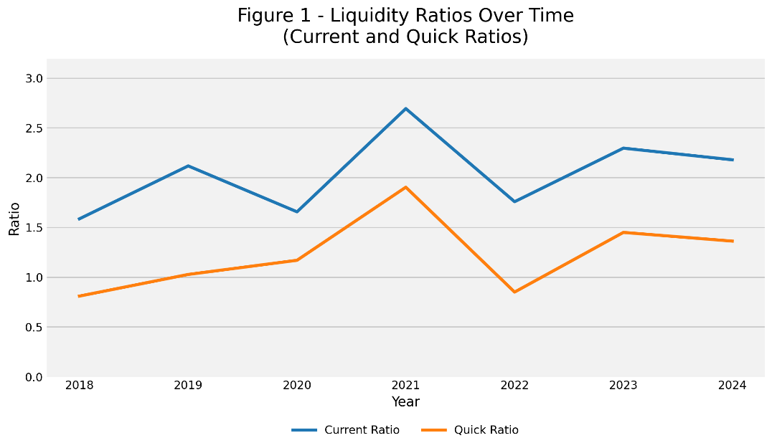

Figure 2: YETI Profitability Margins (2018–2024)
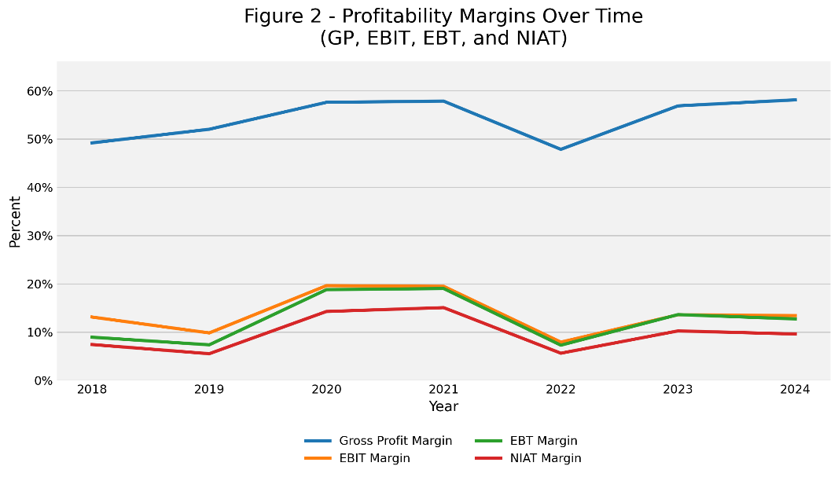

Figure 3: YETI Efficiency Considering AR Turnover, Inventory Turnover, and LT Asset Turnover (2018–2024)
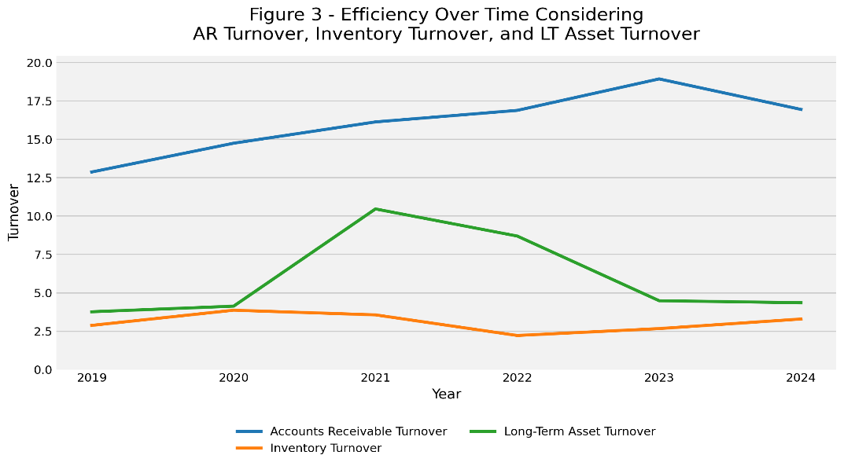

Figure 4: YETI Solvency Ratios (2018–2024)
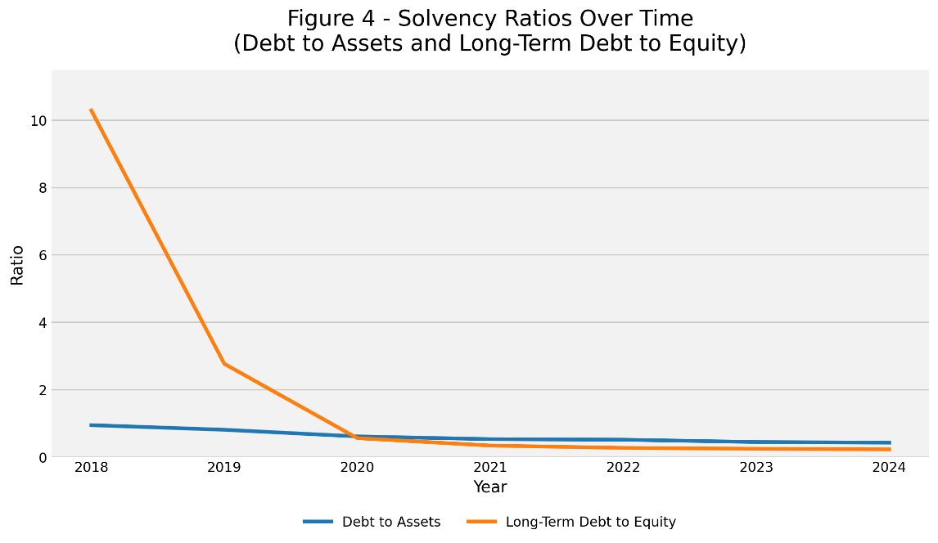

Figure 5: YETI DuPont Return Measures (2018–2024)
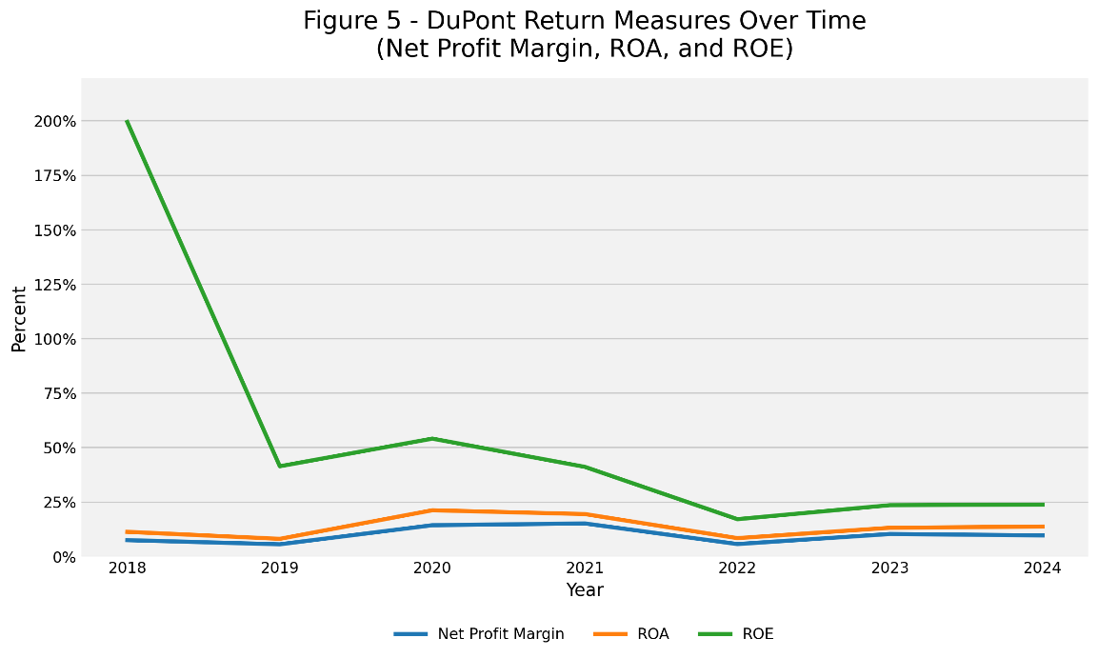

Exhibit D: Base Case Financial Projections (2025–2029)
 | Actuals |  | Assumptions | Projections for
 | EOY 2024 | % of Revenue |  | 2025 | 2026 | 2027 | 2028 | 2029
Net revenues | $1,829,873 | 100.0% | Projected Revenue | $1,921,367 | $1,998,221 | $2,068,159 | $2,130,204 | $2,194,110
 |  |  | Exp. Revenue Growth Rate | 5.0% | 4.0% | 3.5% | 3.0% | 3.0%
Cost of goods sold (COGS) | $766,589 | 41.9% | Product CGS % of Revenue | 42.0% | 42.0% | 41.8% | 41.8% | 41.8%
 |  |  | Projected COGS | $806,974 | $806,974 | $835,257 | $864,490 | $890,425
SG&A expenses | $817,908 | 44.7% | SG&A/Revenue | 45.0% | 45.2% | 45.0% | 44.8% | 44.5%
 |  |  | Projected SG&A | $864,615 | $903,196 | $930,672 | $954,331 | $976,379
EBIT | $245,376 | 13.4% | Projected EBIT | $249,778 | $288,051 | $302,231 | $311,382 | $327,306
Interest expense, net | $660 | 0.0% | Frozen at 2023 Levels | $660 | $660 | $660 | $660 | $660
Earnings before taxes (EBT) | $232,848 | 12.7% | Projected EBT | $249,118 | $287,391 | $301,571 | $310,722 | $326,646
 |  |  | Income Tax Rate | 9.6% | 9.6% | 9.6% | 9.6% | 9.6%
Provision for income taxes | -$57,159 | -3.1% | Projected Income Taxes | $23,918 | $27,593 | $28,954 | $29,833 | $31,362
Net income after taxes (EAT) | $175,689 | 9.6% | Projected Net Income After Taxes | $225,199 | $259,798 | $272,617 | $280,889 | $295,284
Total assets | $10,225 | 0.6% | Projected Total Assets/Revenue | 0.6% | 0.6% | 0.6% | 0.6% | 0.6%
 |  |  | Projected Total Assets | $10,736 | $11,166 | $11,556 | $11,903 | $12,260
Total Liabilities | $- | 0.0% | Projected Total Liabilities | $- | $- | $- | $- | $-
Total Stockholders’ Equity | $405,921 |  | Projected Total SE | $631,120 | $890,919 | $1,163,536 | $1,444,425 | $1,739,709
The “Bottom Line” |  |  | Projected Net Capital Available | $620,384 | $879,753 | $1,151,979 | $1,432,521 | $1,727,448

Exhibit E: Improved Case Financial Projections (2025–2029)
 | Actuals |  | Assumptions | Projections for
 | EOY 2024 | % of Revenue |  | 2025 | 2026 | 2027 | 2028 | 2029
Net revenues | $1,829,873 | 100.0% | Projected Revenue | $1,903,068 | $2,017,252 | $2,118,115 | $2,202,839 | $2,268,924
 |  |  | Exp. Revenue Growth Rate | 4.0% | 6.0% | 5.0% | 4.0% | 3.0%
Cost of goods sold (COGS) | $766,589 | 41.9% | Product CGS % of Revenue | 42.2% | 42.2% | 41.0% | 40.5% | 40.0%
 |  |  | Projected COGS | $803,095 | $803,095 | $827,073 | $857,836 | $881,136
SG&A expenses | $817,908 | 44.7% | SG&A/Revenue | 46.0% | 45.0% | 44.0% | 43.5% | 43.0%
 |  |  | Projected SG&A | $875,411 | $907,763 | $931,970 | $958,235 | $975,637
EBIT | $245,376 | 13.4% | Projected EBIT | $224,562 | $306,394 | $359,071 | $386,768 | $412,151
Interest expense, net | $660 | 0.0% | Frozen at 2023 Levels | $660 | $660 | $660 | $660 | $660
Earnings before taxes (EBT) | $232,848 | 12.7% | Projected EBT | $223,902 | $305,734 | $358,411 | $386,108 | $411,491
 |  |  | Income Tax Rate | 9.6% | 9.6% | 9.6% | 9.6% | 9.6%
Provision for income taxes | -$57,159 | -3.1% | Projected Income Taxes | $21,497 | $29,354 | $34,412 | $37,071 | $39,508
Net income after taxes (EAT) | $175,689 | 9.6% | Projected Net Income After Taxes | $202,405 | $276,380 | $323,999 | $349,037 | $371,983
Total assets | $10,225 | 0.6% | Projected Total Assets/Revenue | 0.65% | 0.65% | 0.62% | 0.60% | 0.60%
 |  |  | Projected Total Assets | $12,370 | $13,112 | $13,132 | $13,217 | $13,614
Total Liabilities | $- | 0.0% | Projected Total Liabilities | $- | $- | $- | $- | $-
Total Stockholders’ Equity | $405,921 |  | Projected Total SE | $608,326 | $884,706 | $1,208,705 | $1,557,742 | $1,929,725
The “Bottom Line” |  |  | Projected Net Capital Available | $595,956 | $871,594 | $1,195,573 | $1,544,525 | $1,916,112

Exhibit F: SWOT Analysis Table
Key Success Factors:  • Strong brand recognition and customer loyalty  • Advanced DTC platform and digital presence  • Customer data analytics  • Efficient global sourcing  • Strong marketing and lifestyle branding  • Product innovation capability  • Sustainable materials and practices  • Supply chain flexibility | Strengths:  • Strong premium brand reputation and loyal customer base  • High-quality, durable coolers and drinkware  • Ability to charge premium prices due to brand equity  • Advanced DTC platform through website and retail stores  • Strong marketing and lifestyle branding  • Continuous product innovation and expansion | Weaknesses:  • Premium pricing limits accessibility for some customers  • Dependence on global sourcing and overseas manufacturing  • Exposure to tariffs, shipping costs, and supply chain disruptions  • Limited flexibility during supply chain disruptions  • Less competitive in lower-price segments
Industry Driving Forces:  • Permanent growth of DTC channels  • Higher logistics and sourcing costs  • Increased sustainability expectations  • Increased competition from smaller brands  • Brand loyalty as a key competitive differentiator  • Global expansion of outdoor recreation markets | Opportunities:  • Growth through expanded DTC channels and digital platforms  • Expansion into new international markets  • Development of innovative products  • Adoption of sustainable materials and practices  • Strengthening brand loyalty through lifestyle branding | Threats:  • Increased competition from smaller and lower-priced brands  • Rising logistics, sourcing, and production costs  • Supply chain disruptions and global trade issues  • Economic downturns impacting discretionary spending  • Pressure to meet sustainability expectations and regulations

Exhibit G: Recommendations Table
Recommendation | Purpose (Strategic, Financial, or Both?) | Years Effects Observed | Where Reflected in Improved Projections
Increase international expansion through localized e-commerce and retail partnerships | Strategic and financial: increases growth and diversification | 2024–2027 | Net sales (international revenue), SG&A (marketing/logistics), Operating Income
Expand production into adjacent premium categories | Strategic: increases brand leverage; Financial: grows revenue | 2024–2026 | Net sales (new product lines), COGS, Gross Margin
Increase the DTC channel as a percentage of total sales | Both: improves margins and builds direct consumer relationships | 2024–2026 | Net sales (channel mix), Gross Margin, SG&A (digital investment)
Diversify supply chain away from heavy reliance on China | Strategic: reduces tariff and disruption risk | 2024–2025 | COGS, Gross Margin, Inventory levels
Optimize pricing strategy to protect premium margins | Both: protects margins and maintains competitive differentiation | Immediate–2026 | Net Sales, Gross Margin
Implement stricter product quality controls and risk management systems | Both: strategic post-recall response and financial cost avoidance | Immediate–2025 | SG&A (quality control), Other expenses (recall costs), Net Income
Continue share repurchase and disciplined capital allocation | Financial: increases shareholder value | 2024–2026 | Shares outstanding, EPS, Cash flow

